**Practical 4**

|  |  |
| --- | --- |
| Roll No. A016 | Name: Varun Khadayate |
| Program: B-Tech (CSBS) | Division: SY |
| Batch: 1 | Date of Experiment: 07-02-2021 |
| Date of Submission: 11-02-2021 | Grade: |

**To draw a sequence diagram for University Enrollment for Students and a 2-party landline phone call.**

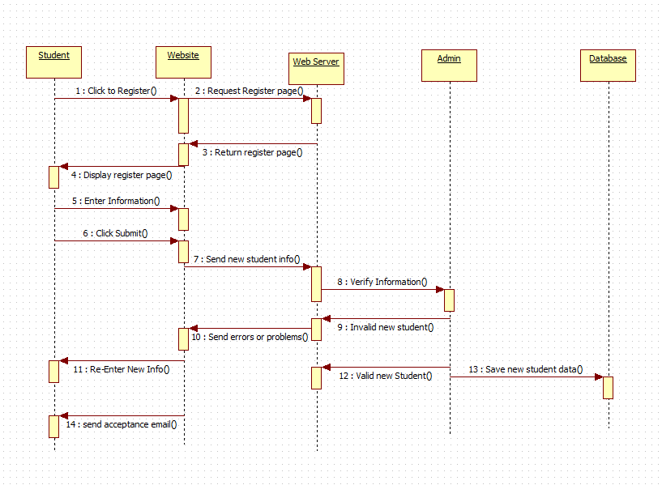

**2-party Landline phone call.**

